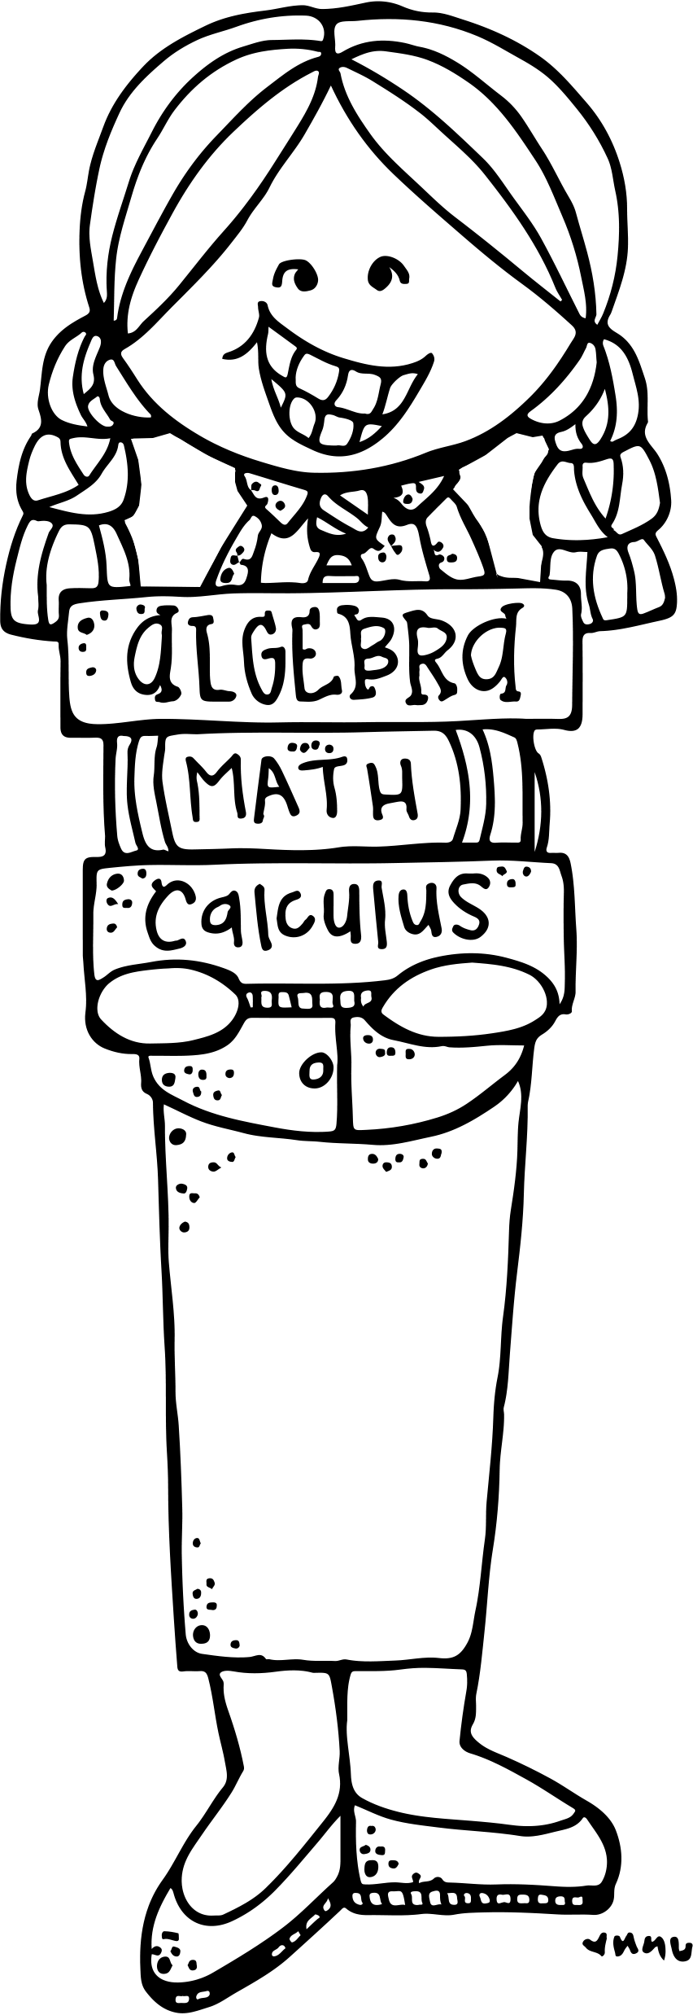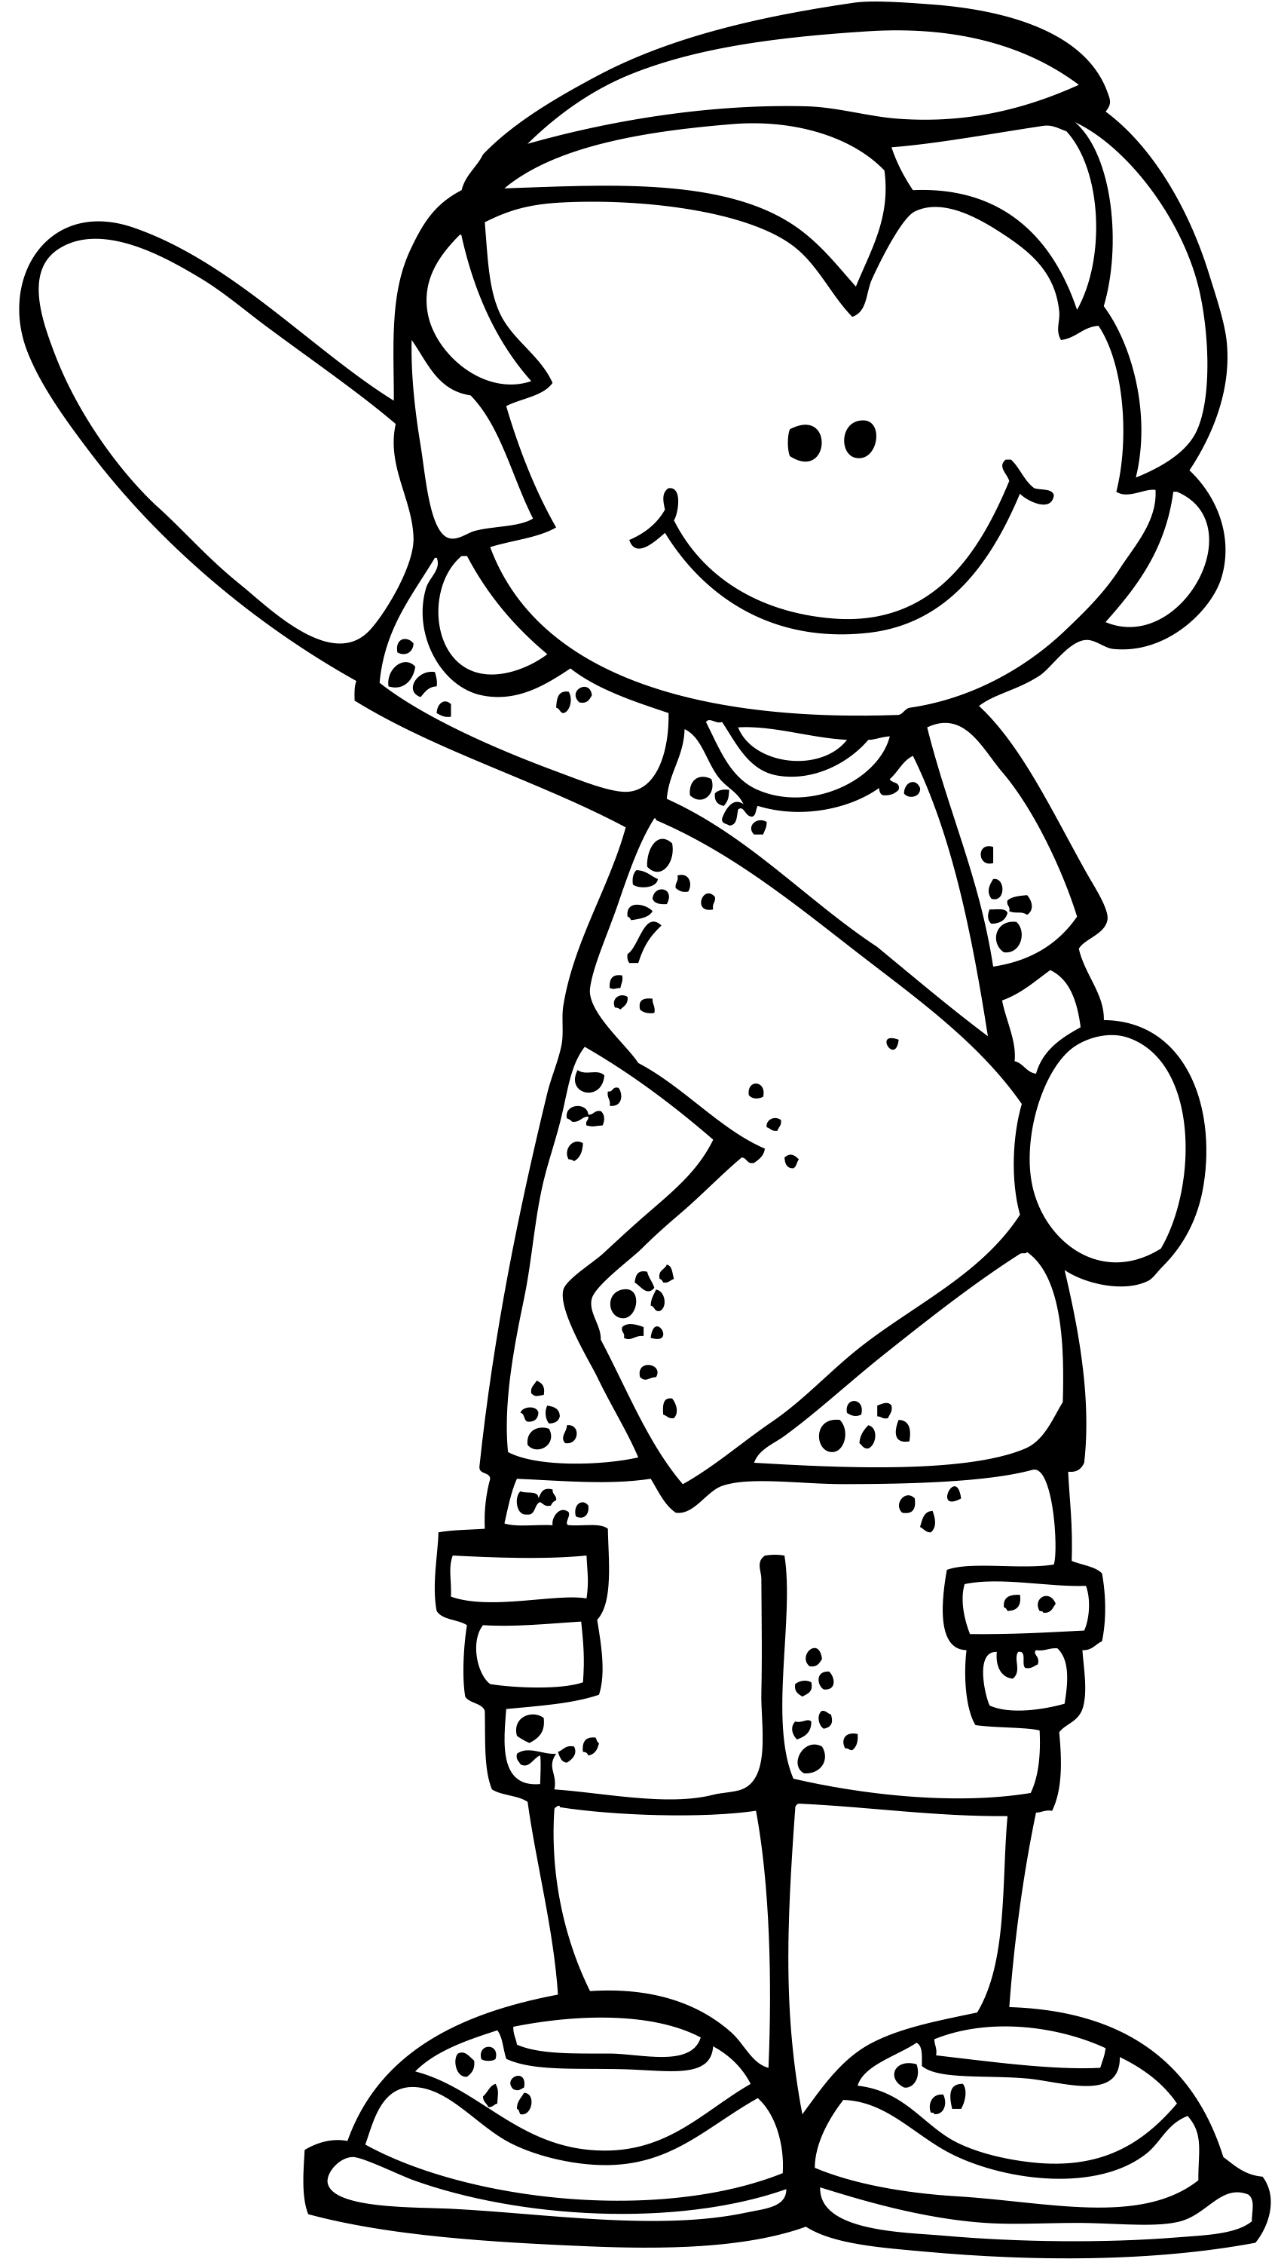**Oakwood Intermediate School – Room 408**

**6th Grade Advanced Math 2017 – 2018**

**TUTORIALS**

Tutorials are available to students who have questions, need help, want extra practice, or need a place to work on assignments. **Schedule coming soon!** ☺  
  
There will be no tutorials when I have morning duty, recess duty (during success), or when I have a sub.

**Ms. Rosales** (979) 764-5530

Email: [mrosaleslagos@csisd.org](mailto:mrosaleslagos@csisd.org)

Webpage:

<http://rosalesdlmath.weebly.com/>

Huskies Team Webpage:

<https://sites.google.com/a/csisd.org/dual-language/>



**NAME – DATE - PERIOD**

ALL assignments will have a correct heading at the top of the page. Assignments without a correct heading could be considered late and/or have points taken off.

**ABSENCES**

Students are responsible for checking with their teacher for work missed when they leave early, arrive late, or miss school due to an absence.

**REQUIRED MATERIALS**

All students are required to have these materials with them in class, daily.

* Pencil Pouch w/ plenty of pencils, erasers, pencil sharpener, grading pens (any color, but black), blue or black dry erase markers, & glue stick.
* 2 or 3-inch Binder
* Blank Lined Paper
* Ear Buds

**REMIND**

Please sign up for REMIND – parents & students! I will send out reminders about due dates.

TO: 81010

TEXT: rosalesadv



Please see me when you miss class.

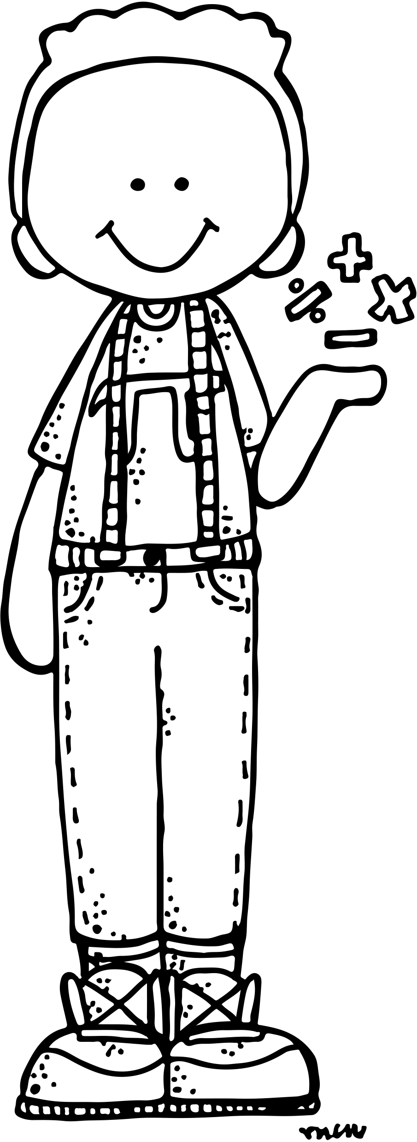

**OAKWOOD PRIDE**

**P** – Prepare for Success.

**R** – Respect Everyone.

**I** – Include Others.

**D** – Do What Is Right.

**E** – Expect Great Things!



Macintosh HD:Users:khryscarter:Desktop:Screen Shot 2017-08-16 at 5.39.52 PM.png

All work completed to be turned in, MUST be completed in pencil. Work completed in pen, colored pencil, crayon, or marker

**BINDERS**

* Binders may be kept NEATLY on a shelf in the classroom.
* Binders MAY go home at any time.
* Binders MUST go home before a test.
* We will “clean out” binders as a class.
* Pages are kept in order according to the date – earliest date 1st.
* BINDER TABS:
  + Bellwork
  + Notes & Classwork
  + Homework
  + Reviews, Tests, & Projects
  + Reference & Glossary

**PENCIL ONLY**

**HOMEWORK CLUB**

Students may check COMPLETED homework assignments during morning tutorials with a pencil. Students may ask QUESTIONS to get clarity and make CORRECTIONS without penalty.

**HOMEWORK 5-DAY RULE**

Late homework will be accepted up 5 school days after the original due date. After the 5 days the grade will remain a zero in the gradebook.

will not be accepted.

**TEST CORRECTIONS**

Students who makes below a 75/C on a test can make test corrections to bring up the grade to a 75/C. Test Corrections will include a re-teaching assignment with your teacher and a re-test. Students must get both the re-teaching assignment and the re-test correctly completed before the next unit test or the end of the six weeks (whichever comes first).

**APPS USED IN CLASS**

* Socrative Student
* Kahoot
* Nearpod
* QR Code Reader (any)
* Others TBA

Please remember to keep your device face down & on silent until I ask you use it.



**HOMEWORK**

Completing math homework is ESSENTIAL to SUCCESS in math. Expect homework in math EVERYDAY (except Fridays, holidays, and test days). Unless stated otherwise, homework is due the NEXT day. Homework should be completed NEATLY and in PENCIL. Incomplete homework will NOT be accepted.

PLEASE come see me if you need help with your homework.

**KEEP   
CALM &**

**SHOW   
YOUR   
WORK**

**2018 MATH STAAR**

MONDAY,   
MAY 14th